**Visual Programming**

**MVC Assignment**

**Muhammad Shaheer**

**213008**

**Project: Basic To-do List Web App**

**Description:**

A basic to-do list web app using ASP.NET MVC and SQLite follows the MVC architectural pattern to manage to-do items, interacts with a SQLite database for data persistence, and provides users with an interface to view, add, update, and delete to-do items within a web browser.

**Model:**

Represents the data of the application (tasks in this case). It interacts with the database (SQLite) to store and retrieve tasks.

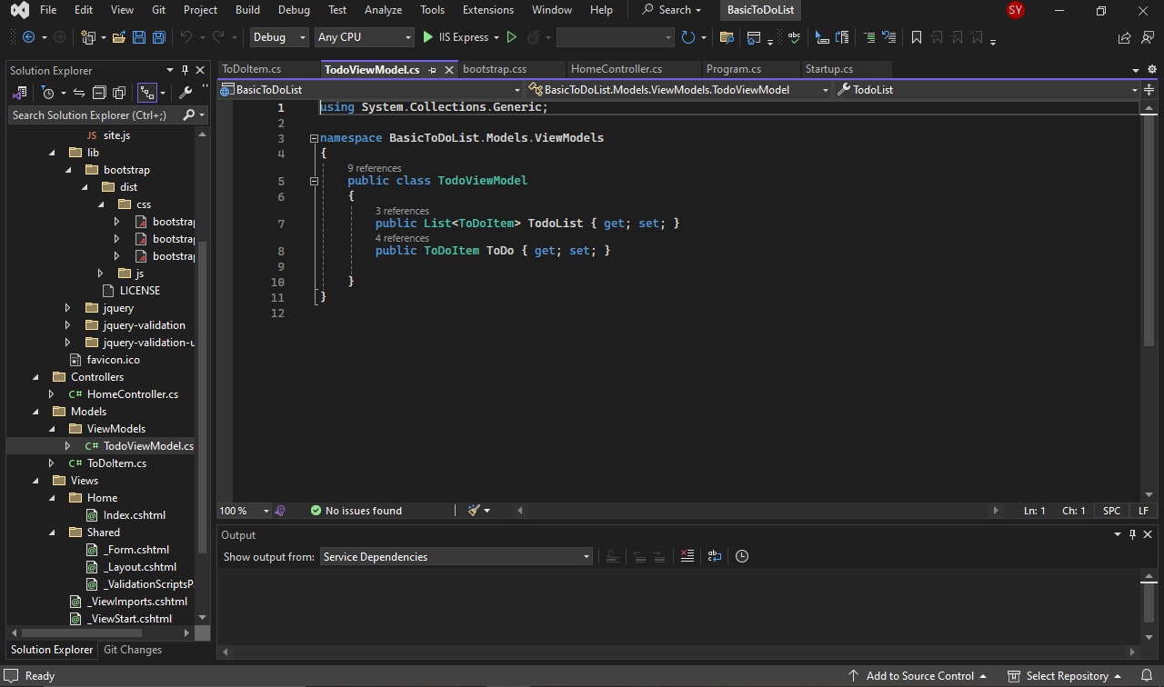

**View:**

Handles the presentation layer, providing the user interface to interact with the app. It comprises HTML, CSS, JavaScript, and possibly Bootstrap for styling.

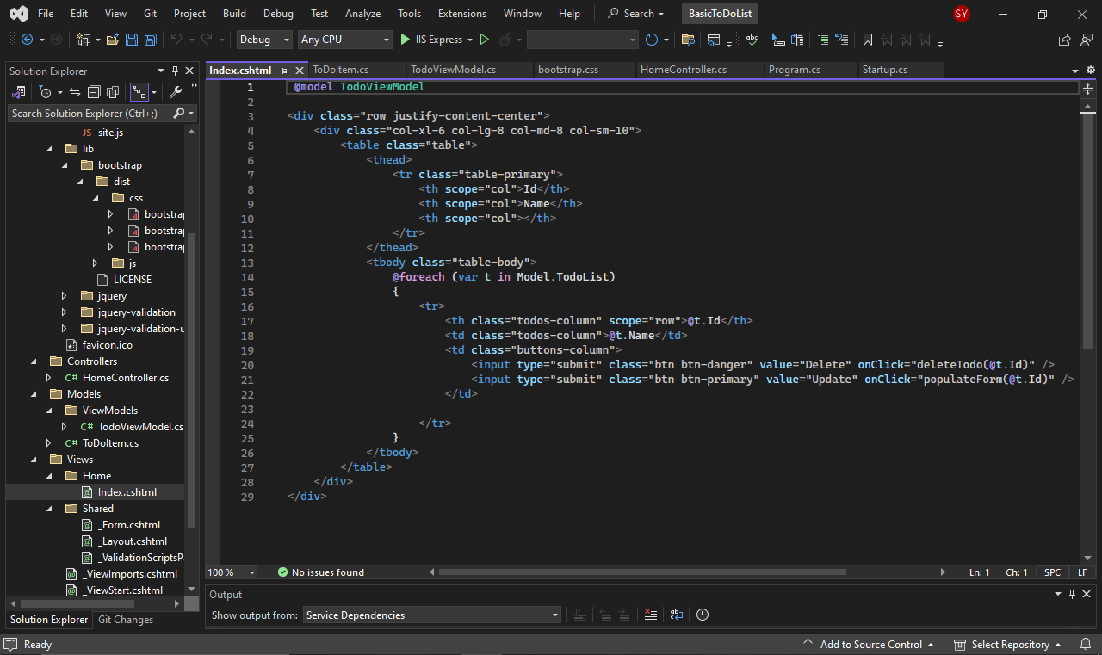

**Bootstrap:**

A front-end framework used for creating responsive and appealing designs.

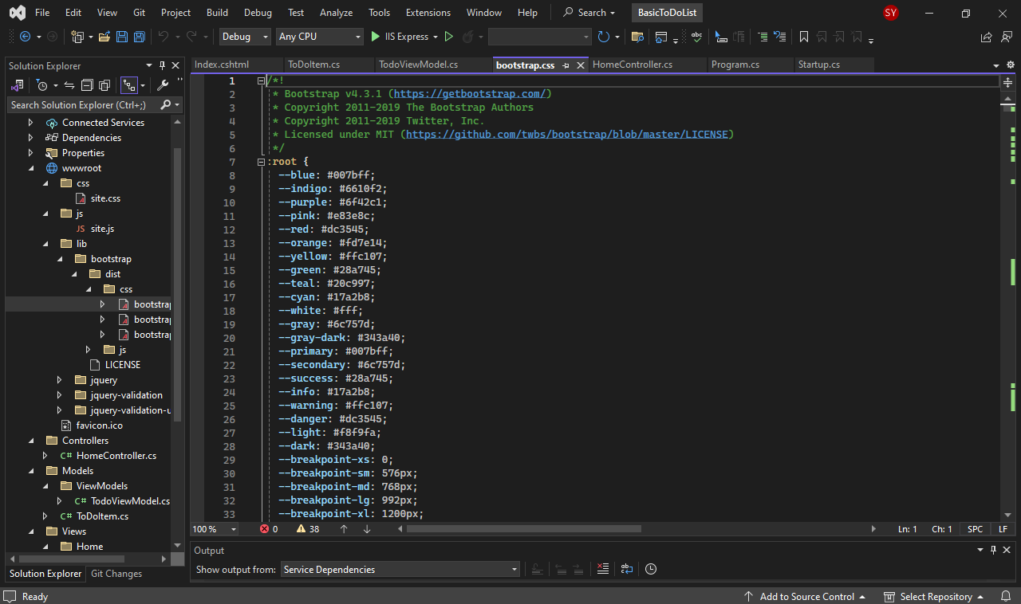

**Controller:**

Acts as an intermediary between the Model and View, handling user inputs, managing data flow, and updating the Model or View as needed

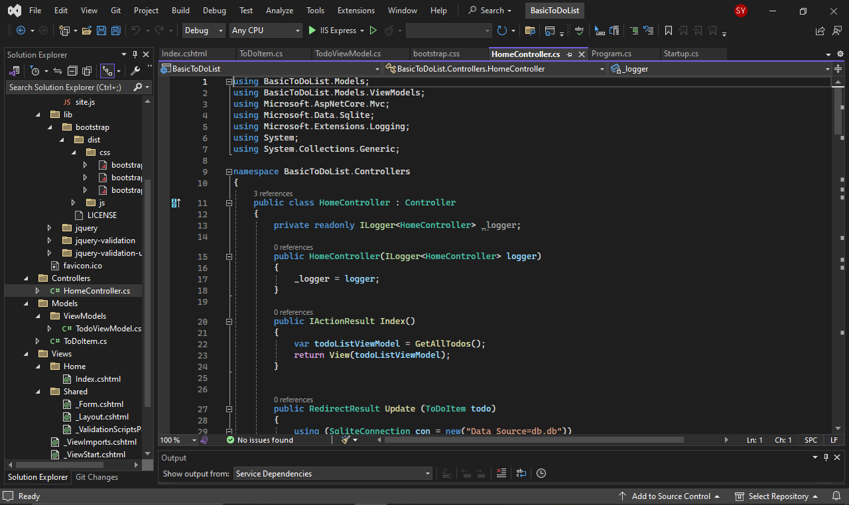

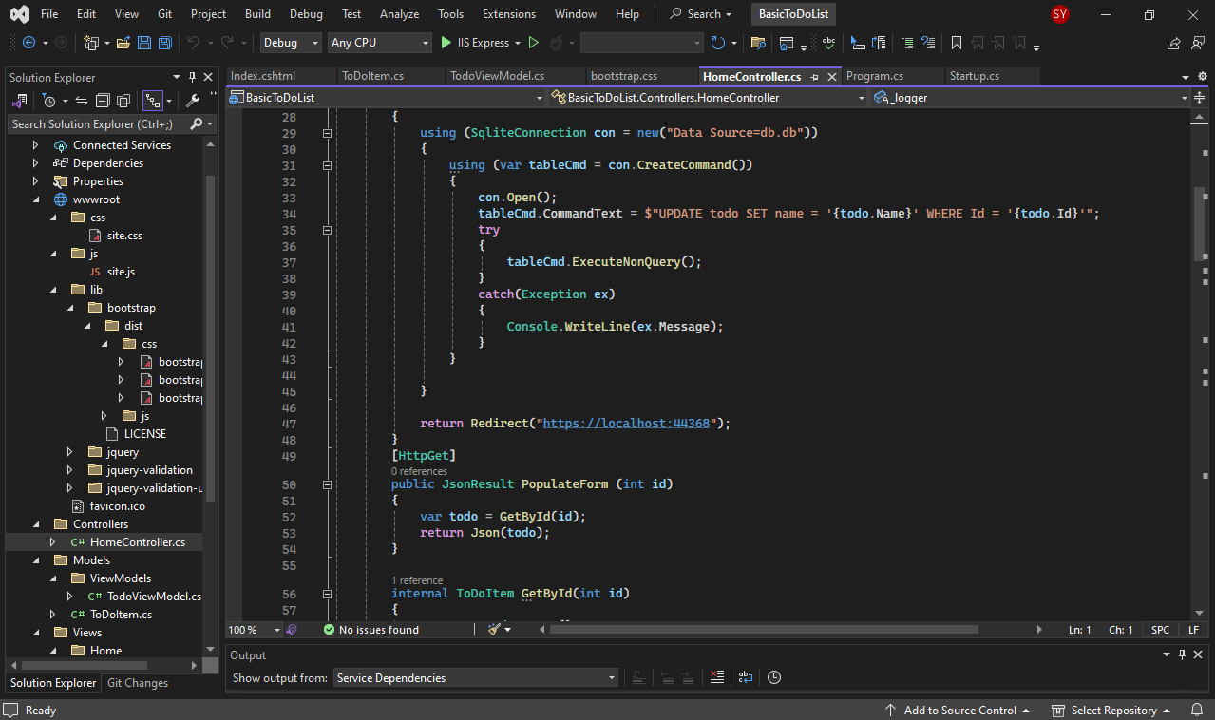

**Errors:**

I got a problem while connecting with the **Database**. I used SQLite database engine to connect my app. The database was not connected with the local server. So, I created a local server in the Visual Studio 2022 and then connect the server to my App.

Here I created a Local Server:

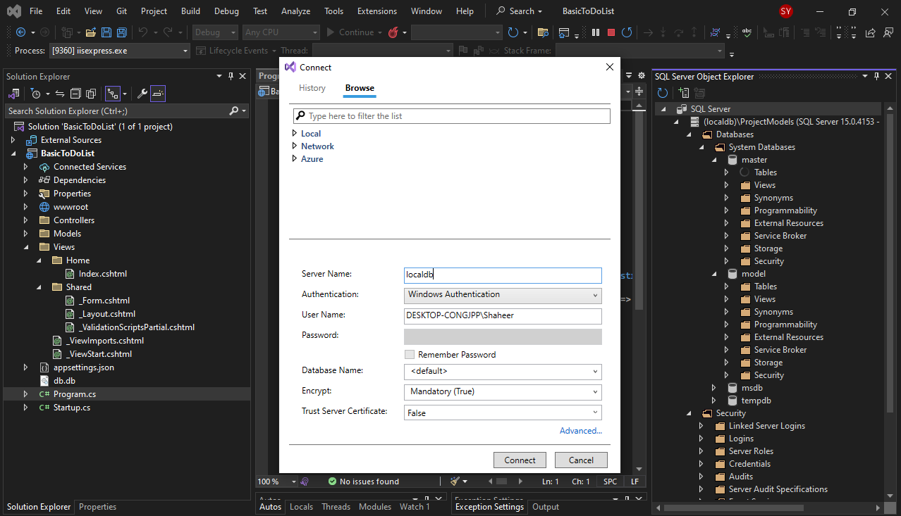

Then I added into my Database:

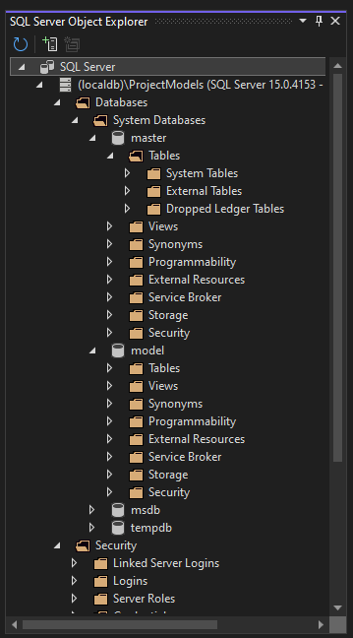

**Output:**

This basic TODO-List app performs CRUD (Create, Read, Update, and delete) Operations.

